Guide to Using the Australian Immunisation Register (AIR)

Please note: This is a live document. For the most up to date information about the AIR go to:
https://www.humanservices.gov.au/health-professionals/services/medicare/australian-immunisation-register-health-professionals

Introduction to the Australian Immunisation Register
The Australian Immunisation Register (AIR) formerly the Australian Childhood Immunisation Register (ACIR) is a national register that records vaccinations given to people of all ages in Australia. This expansion includes adult vaccines such as those given for whooping cough, shingles, influenza and travel.

The AIR:

- is used to monitor immunisation coverage levels and service delivery, and to identify regions at risk during disease outbreaks;

- can provide reports to vaccination providers upon request to help identify individuals who are due or overdue for immunisation;

- makes an information payment to vaccination providers who administer and notify the AIR of a completed National Immunisation Program (NIP) vaccination schedule for children under 7 years of age; and

- makes an additional incentive payment to vaccination providers who follow up and vaccinate children under 7 years of age who are more than 2 months overdue for their childhood vaccinations.

Data from the AIR:

- enables the vaccination provider to check the immunisation status of an individual, regardless of where they were immunised;

- is used to create an Immunisation History Statement;

- provides information about a child or young individual’s immunisation status to help determine eligibility for Child Care Benefit, Child Care Rebate and Family Tax Benefit part A supplement;

- provides evidence of immunisation for those working with vulnerable people, such as those in health, aged care and child care; and

- is used to measure coverage at a national, state and territory, and local level.

Information taken from: Australian Government Department of Human Services website:
humanservices.gov.au/hpair

The Department of Health highly recommend that as part of the immunisation service provided to these individuals, recognised vaccination providers need to send the immunisation details of their clients to the AIR. The benefits to both the vaccination provider and the individual are profound.

This document aims to assist vaccination providers with the use of AIR and its utilities to ensure the timely transfer of immunisation encounter data to the AIR so individual’s records are up to date. In addition, the AIR data allows vaccination providers to follow up on individuals who have become overdue for their vaccinations.
CONTENTS:

Page

Introduction to the Australian Immunisation Register (AIR) 1

Contents 2

Benefits of having access to the AIR 3

Request AIR access - General Practitioners 4

Register and Request AIR access - Other Vaccination Providers 5
Initial Logon to the AIR with an Authentication Filename 6

Logging onto the AIR 8

Identify Individual and Entering Immunisation Encounters and/or
History onto the AIR 9

AIR Secure Email 14

Reports available from the AIR site 15

Requesting and retrieving AIR Reports 16

Claims Summary and Statement of Payment 24

Useful forms 25

AIR Information for Health Professionals 26

AIR contact details 26

BENEFITS OF HAVING ACCESS TO THE AIR

- quick access to check the immunisation status of individuals;

- utilisation of the AIR secure email - to advise AIR of individuals who have moved away, are overseas, who are un-contactable or various other reasons;

- request and receive automated overdue reports to follow up individuals requiring vaccination (reports can be set up to 12 months in advance); and

- ability to request claims summaries to ensure immunisation data is transferring from Practice Management Software to the AIR and secondly the affiliated provider notification payments are therefore being received by the vaccination provider.

Please note:
This guide is based on users logging on to the AIR using the authentication method.
Vaccination providers can access the AIR through Health Professionals Online Services (HPOS) to submit immunisation records, view an immunisation history, request reports and update provider contact details.
Read more about accessing the AIR using HPOS:
humanservices.gov.au/hpos

REQUEST AIR ACCESS FOR GENERAL PRACTITIONERS
Do you have access to the AIR?

YES
NO

Proceed to logging on to the AIR- page 8

General Practitioners are automatically recognised as vaccination providers and are authorised to send or receive immunisation data from the AIR.

To request access: If you have access to HPOS, you can request access to the AIR by completing the online request access page. Access is granted overnight.

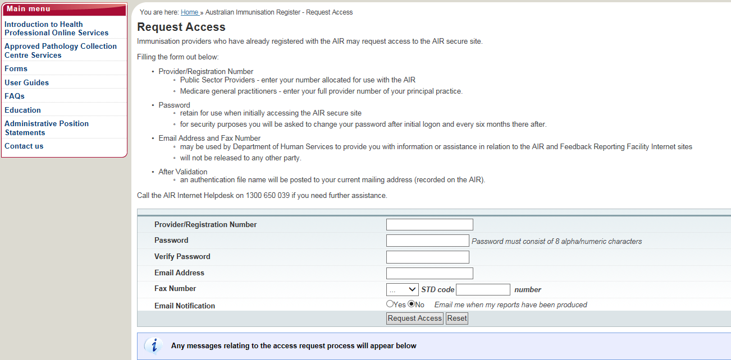

If you are a general practitioner and do not have access to HPOS apply for a PRODA account and when completed fill in the online request access page.
If you are not a general practitioner, complete the Australian Immunisation Register (AIR) – application to register as a vaccination provider form (IM004).
If you are a general practice with a group of two or more general practitioners wanting to submit AIR data under one practice number and receive all AIR payments into one nominated bank account – you may apply as an organisation by following the steps as outlined under: Register and Request AIR Access: Other Vaccination Providers.

Register and Request AIR access: Other Vaccination Providers
If you are not a general practitioner, you may still be recognised as a vaccination provider.
Register:
- Complete the ‘AIR Application to Register as a Vaccination Provider’ form (IM004) humanservices.gov.au/forms and send it to the WA state health department for approval.
- Once the WA State Health Department has approved the form, it will be returned to you and then you must forward it on to the AIR for registering you as a vaccination provider.
- When the AIR receives the approved form, a registration number is allocated to identify you as a vaccination provider.
- You will receive a letter detailing your AIR registration number. Use this number when you send immunisation details to the AIR. Follow the instructions below to request access to the AIR site.

INITIAL AIR LOGON WITH AUTHENTICATION FILENAME

- Once you have received the authentication filename you can logon to the AIR site by selecting AIR logon only on the HPOS home page humanservices.gov.au/hpos.

- The screen shot below shows the AIR Logon page.

- The authentication file needs to be downloaded. To start this process select click here.

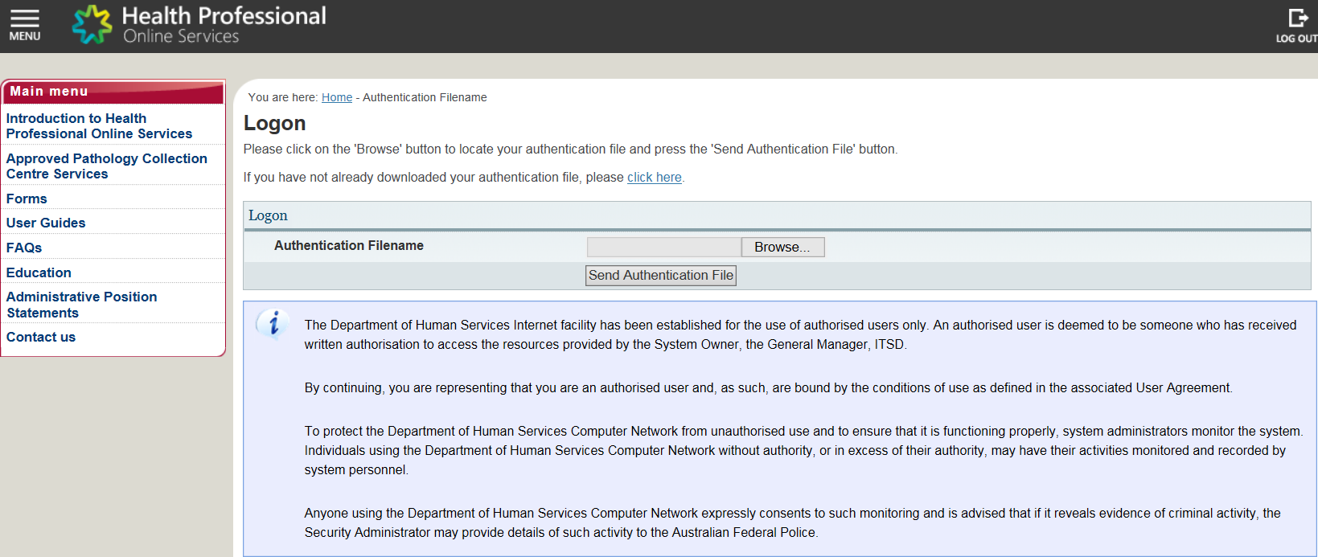

- The example below shows how to Obtain Authentication File by entering in the required username and authentication filename and selecting download file.

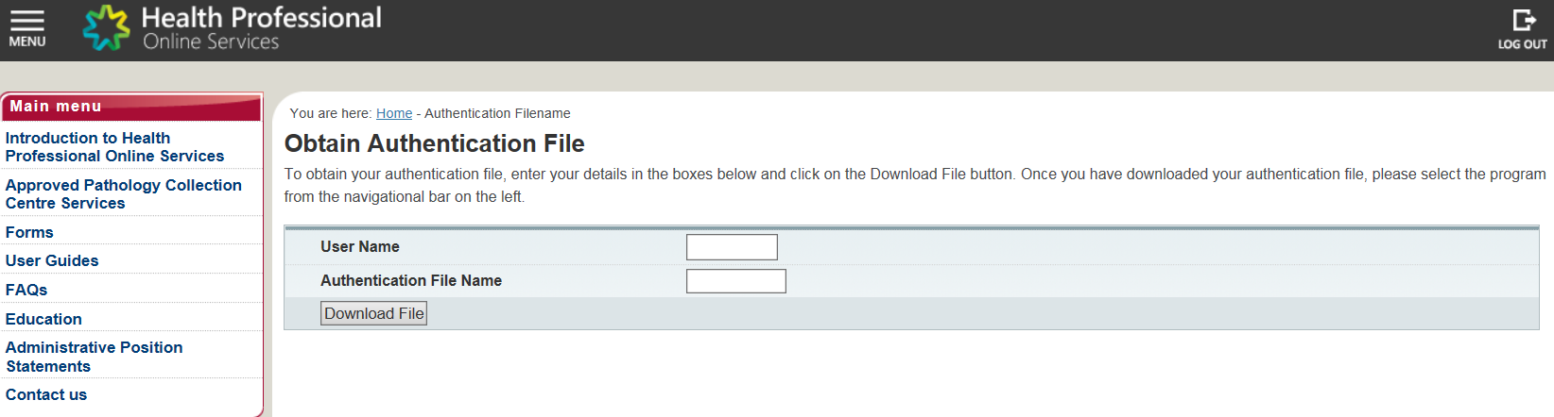

- You will need to save the authentication filename on to your computer. It can be saved on multiple computers. The example below shows the pop up box at the bottom of the screen where you can select to save the authentication filename to a folder that the relevant staff can access. The filename entered must remain the same or the system will not recognise it. For example, abc@123.ht must remain the same.

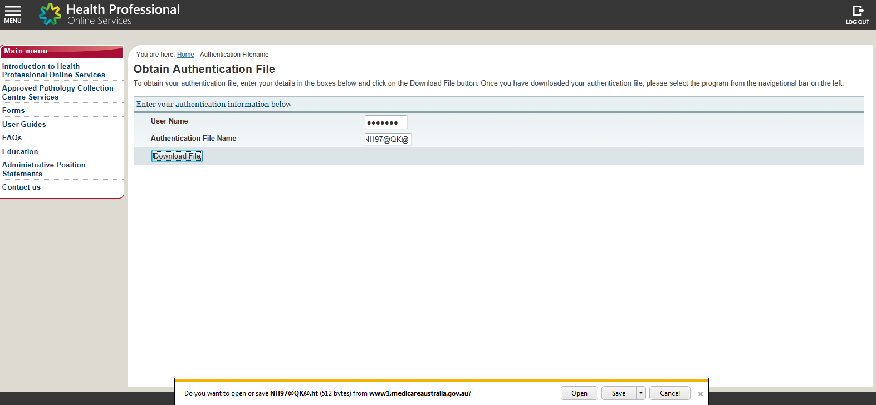

- After selecting the authentication filename, the pop up box in the example below will appear and you will be required to enter the username and password. Select ok and you will now be able to access the AIR site.

- The password will be the one you used when initially requesting access. The system will then prompt you for a new password.

- It is also recommended that you save the logon details (username and password) required for access to the AIR site in a saved folder that only those able to utilise it have access to. The password will require changing every 6 months. You will be prompted to do this by the AIR at the time when logging in to the AIR site.

LOGGING ONTO THE AIR

Go to: humanservices.gov.au/hpos

- Enter in the required authentication filename, username and password.

Once you have logged on to the AIR – the AIR Main Menu will appear as below with the following options:

- Reports Menu - lists the reports available for you to produce;

- Claims Menu - allows you to display details of claims submitted to the AIR and your current Statement of Payment;

- Identify Individual - allows you to display the immunisation history for an individual;

- Provider Menu - allows you to amend your Internet contact details; and

- Email secure site – Access gained through the Secure Email link on the left hand side of the Main Menu (see page 14 for further details about using the secure site email).

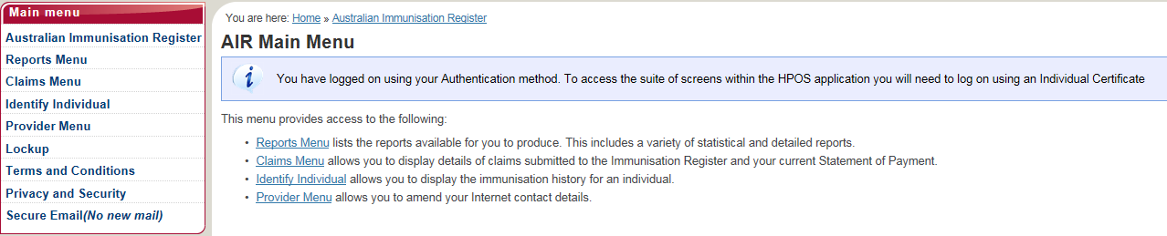

IDENTIFY INDIVIDUAL AND/OR ENTERING IMMUNISATION HISTORY ON TOTHE AIR
- Once logged onto the AIR, select Identify Individual from the options listed on the AIR Main Menu page.

- If the individual is registered with Medicare they will have an AIR record.

- If the individual is not registered with Medicare (e.g. 457 or student visa) you can create a new record for the individual.

- Initially ensure that the individual does not have an AIR record by searching for the individual. This is important because if a duplicate record is created, their family assistance payments may be affected until the record can be matched. This is done by entering the first name, surname and DOB then select Identify Individual. If the details are not recognised by the AIR the message in the example below may be displayed.

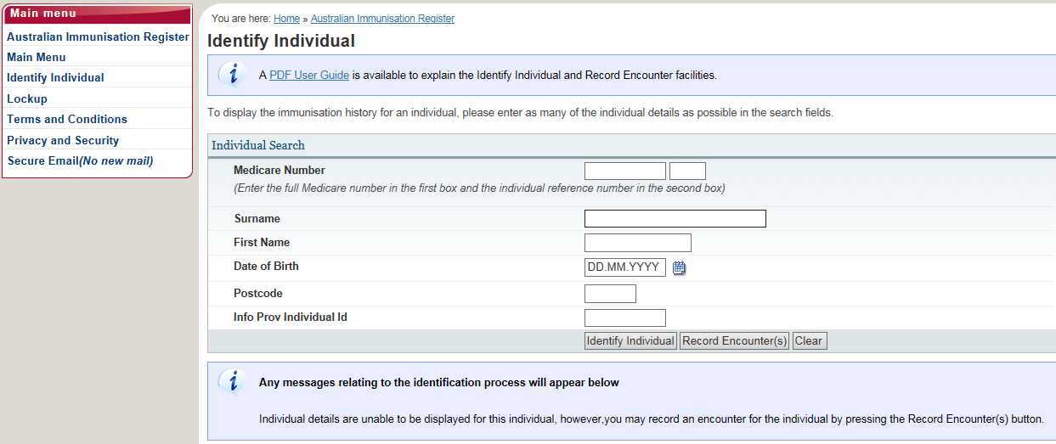
- Only a unique match will display an individual’s AIR record.

- If you are certain there is no record (i.e. the individual is not on the AIR with another name or different spelling) enter the individual’s details and then select Record Encounter.

- The following 2 examples show the Record Encounter page after either a child or adult has been identified or a new record has been created:

Child:

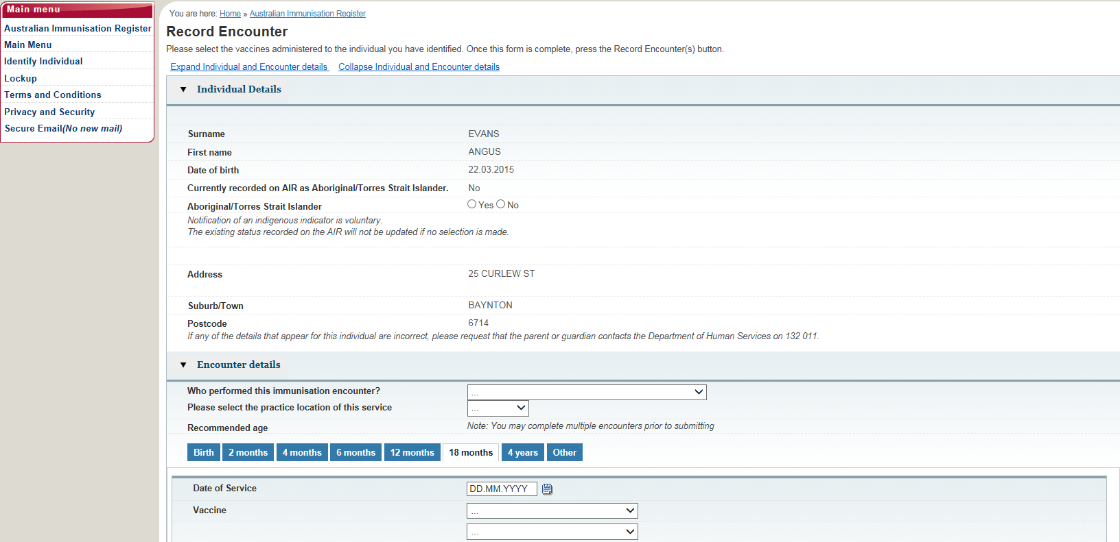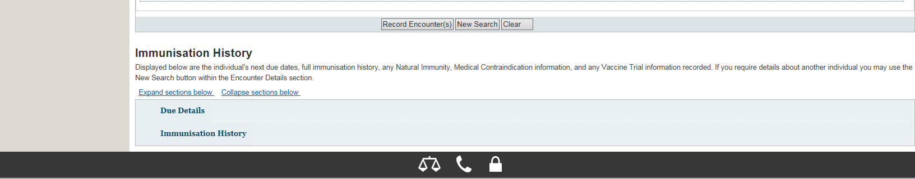
Adult:

Proceed to enter the immunisation encounter and/or history by:

Selecting from the following options:

Who performed this encounter?

- I performed this encounter.
- Another provider performed this encounter in Australia.
- This encounter was performed overseas.

Recommended age: For individuals <20

- Options: Birth/ 2 months/ 4 months/ 6 months/ 12 months/ 18 months/ 4 years/ Other

For each scheduled age point you will be required to put in the date of service and then select the appropriate vaccinations that were administered from the drop down box/es.

- The Other tab option lists all the vaccines including brand names and generic names.

Select Vaccine Brands: For individuals >20

- Options: A – F/ G – O/ P – Z/ Generic

Next step:

- Once you have entered all the vaccines given select Record Encounter.

- If there are multiple dates on which vaccines were given these can all be entered prior to selecting Record Encounter.

Please note:

- The AIR does not display the immunisation history immediately. Check later to make sure the immunisation history has been entered correctly.

- If an amendment is required for an immunisation history encounter i.e. vaccine brand dose you can send a secure email through the AIR site.

- The Immunisation History form (IM013) or Immunisation encounter form (IM002) available at humanservices.gov.au/forms may be completed and posted to the AIR if you do not have internet access.
- You should advise your patients if you are lodging a manual form as their records will not be updated until they are received by the AIR and processed. This may temporarily affect family assistance payments.

Please note: Below is an example of information included on an Immunisation History Statement and displays immunisation history and the next due date details.

Please check the individual’s immunisation history and due date details to ensure that all vaccinations given are recorded.

Natural immunity and medical contraindication information received by the AIR will also be displayed here.

From June 2017 approved exemption vaccination providers will be able to advise the AIR of medical contraindications and natural immunity online using the AIR site. This will be the quickest way to record exemptions and your patient’s record to be updated.

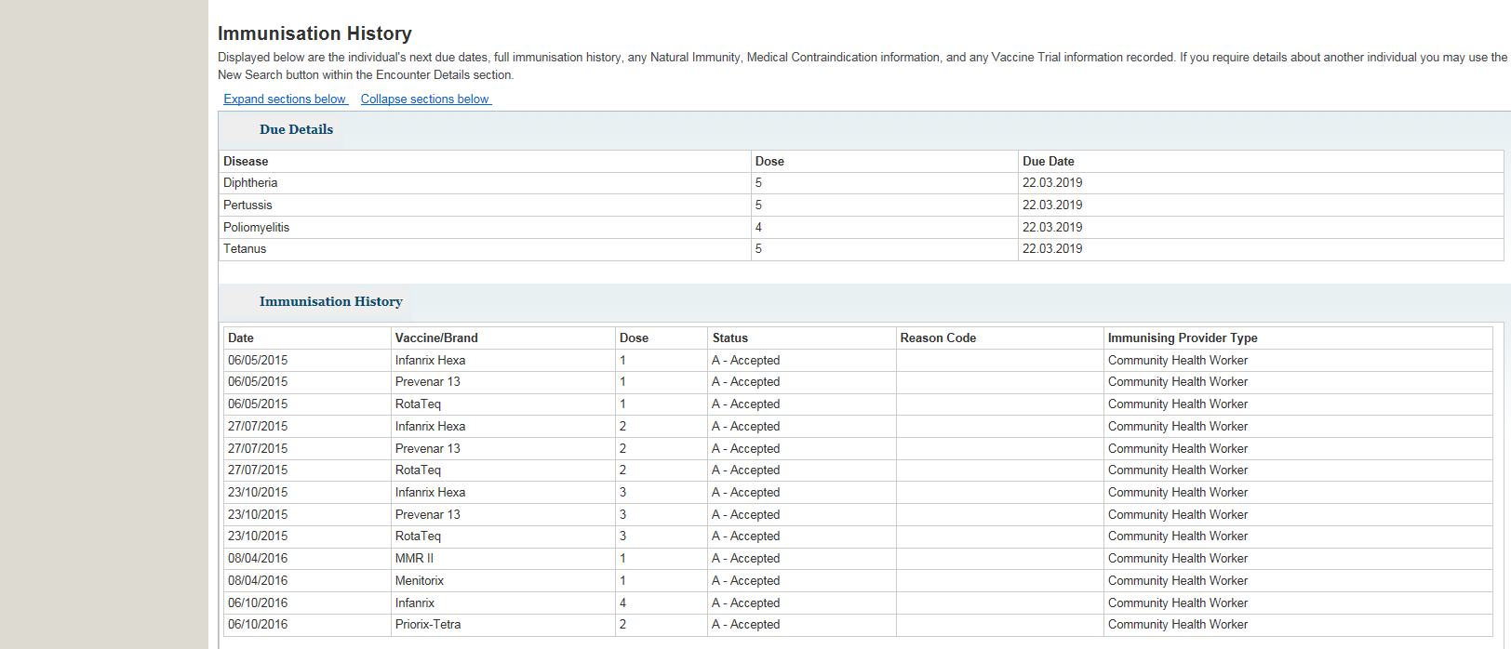
AIR SECURE EMAIL:

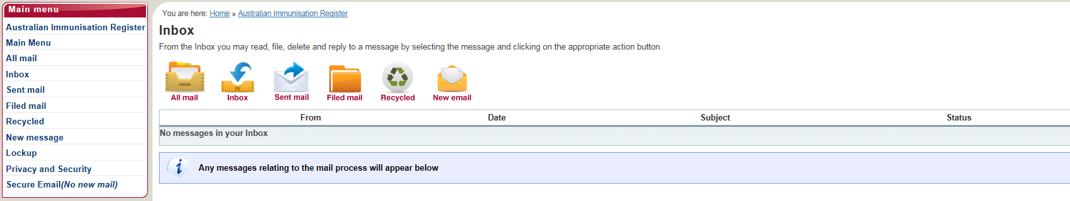

Contacting the AIR using secure email:

The AIR secure email should be used to communicate:

- Corrections or modifications to immunisation details recorded on the AIR, corrections to a vaccination date of service or vaccine brand name.

- That an individual is no longer contactable (i.e. no response to mail sent or calls made by provider). The AIR will flag this on the individual’s record if notified.

- A vaccination provider will be able to flag that an individual is no longer contactable.

Please note: A vaccination provider can identify an individual and view an immunisation history and is able to record an ‘encounter’ via the AIR site, but is unable to view address details. Recording an encounter will remove the individual’s details from the vaccination provider’s overdue reports.

- That an individual has moved outside of the vaccination provider’s locality or moved overseas. If notified, the AIR will also flag this on the individual’s record.

Please note: This will remove the individual’s details from the provider’s overdue reports. Provider is unable to view individual’s details, and or, immunisation history however is still able to record immunisation via the ‘Record Encounter’ function on the AIR site.

- An individual will not appear on overdue reports where an end-date has been recorded on the AIR; the exception is if the end-date is in the future.

- If notified, the AIR can put a temporary end date for individuals who are temporarily overseas. This can be lifted at any time by notifying the AIR;

- The end date will be removed once the AIR has been notified. If an encounter occurs prior to the end date, the end date is not lifted and remains. This would likely ‘pend’ the data and require manual processing by the AIR staff;

- If an individual returns prior to the end date on the AIR, it is best to remove the end date prior to recording an encounter by contacting the AIR. (However, if an update is made via Medicare, on a [Group Record] this may override the end-date recorded on the AIR).
- From the Inbox in the Secure Email you may read, file, delete and reply to a message by selecting the message and the appropriate action button.

Do not use the secure email function to submit new, or confirm existing immunisation details. You can submit new immunisation details through the record encounter function (as explained in previous steps).

REPORTS AVAILABLE FROM THE AIR SITE

The AIR produces a number of statistical, identified and access reports for vaccination providers registered to use the AIR site.

The reports listed below are made available based on the type of provider that has made the request. The provider type is established when the provider registers with the AIR.

Statistical reports:

- AIR001A: Number of individuals registered with the AIR
- AIR002A: Number (or percentage) of individuals who have received valid vaccinations
- AIR002B: Number of individuals who have received valid vaccinations, by a selected provider
- AIR003A: Number of individuals whose consent has been withdrawn
- AIR004A: Number (or percentage) of valid vaccinations by provider type
- AIR005A: Number of providers who have submitted valid vaccination information to the AIR

Identified reports:

- AIR010A: Due/Overdue Immunisation– by Practice Report
- AIR011A: Due/Overdue Report - by Locality
- AIR011B: Due/Overdue Report – by Vaccination Provider
- AIR012A: Database exchange report
- AIR015A: History update report
- AIR016A: Provider contact details
- AIR018A: Immunisation Practice Report for Primary Health Networks
- AIR021A: Due/Overdue Report- by Medicare GP

Access report:

- AIR031A: Internet access statement

REQUESTING AND RETRIEVING AIR REPORTS

Log on to the AIR and select Reports Menu from the AIR Main Menu page

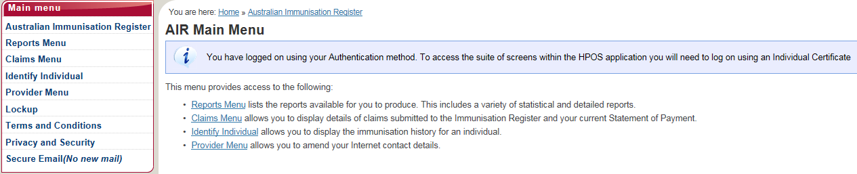

The following options will appear:

- Request a Report lists the reports available for you to produce.

- Modify Reports allows you to modify previously requested reports or delete an existing report request.

- View Reports allows you to display and/or download reports you have previously requested.

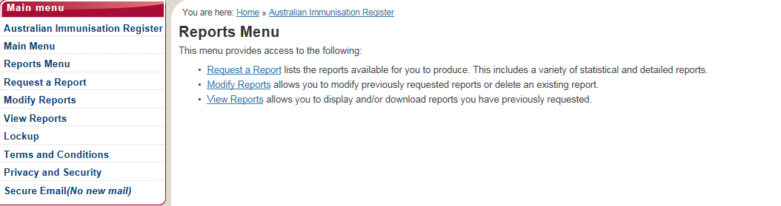

- Select Request a Report.

- The Request a Report page will display the reports made available based on the type of provider that has made the request.

The following steps are based on requesting an AIR011B – Due/Overdue Report – by vaccination provider:

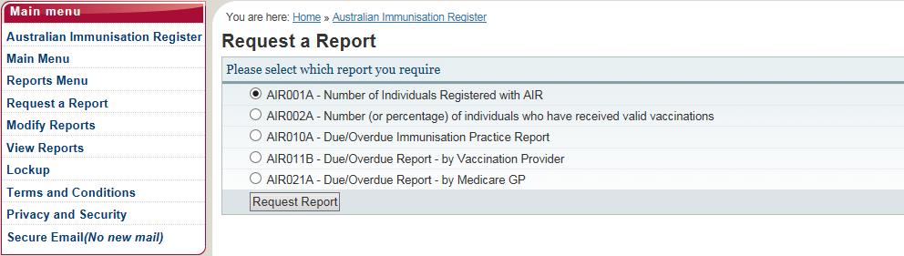

The Request New Report page will display. You will need to select an option to indicate the purpose for which you intend to use the information in the report (you can select up to 4 options).

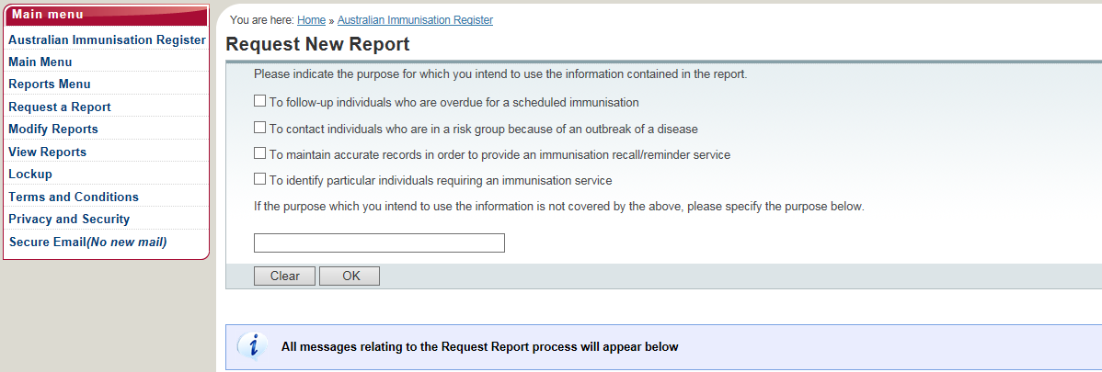

The following pages will display the report fields required to access the following reports:

AIR011B: Due/Overdue Report – by vaccination provider
Report Fields

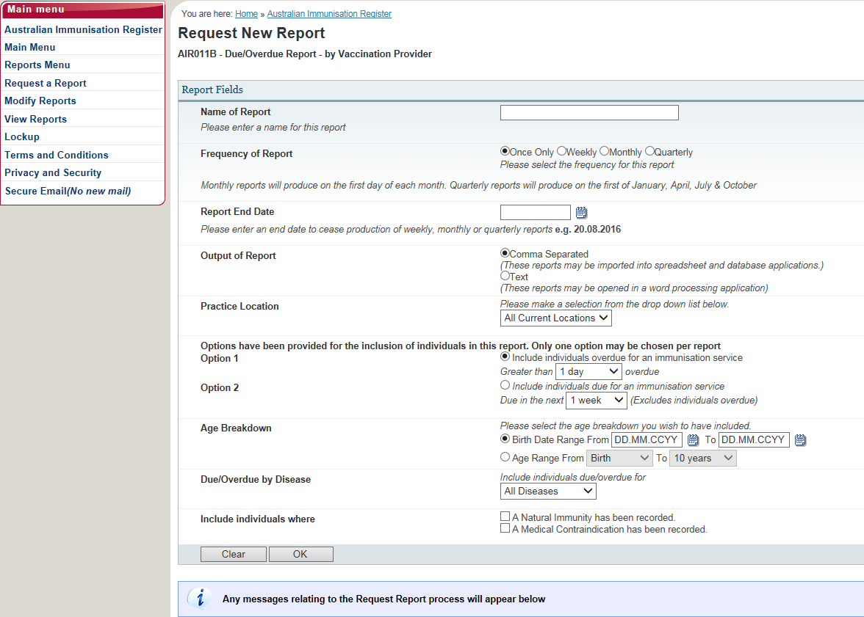

Additional information regarding report fields needing to be completed:

- Name of Report

- Frequency of report (once only, weekly, monthly, quarterly). Monthly reports will produce on the first day of each month. Quarterly reports will produce on the first of January, April, July and October. Once only reports will produce overnight.

- Report end date (allows you to receive these automated reports for up to 12 months in advance) enter an end date to cease production of weekly, monthly or quarterly reports.

- Output of report (recommend comma separated formatting), Option 1 – include individuals overdue for an immunisation service or Option 2 – include individuals due for an immunisation service (excludes individuals overdue).

- Age breakdown select an age range for individuals you wish to include, e.g. < Birth > to < Under 10 years >. The maximum age range permitted is 10 years.

- Due/Overdue by Disease (recommend that you select all diseases).

- Include individuals where – a natural immunity has been recorded, a medical contraindication has been recorded.
- Select OK once fields have been completed.

- Select details you wish to appear on the report :

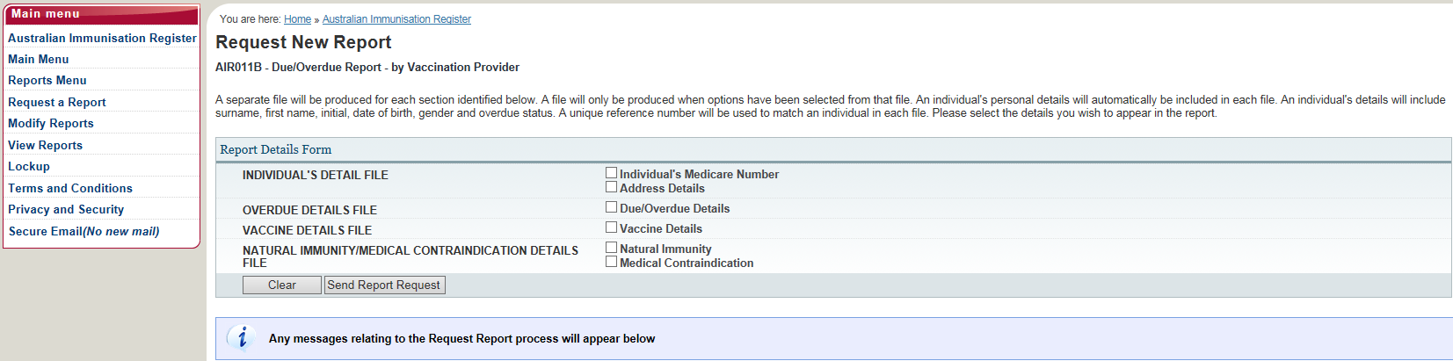

- Select Send Report Request

- If all fields have been completed, the following page will appear advising your request for the report has been successful. The report will be displayed on the View Reports page once it has been produced, which can take up to 30 minutes.

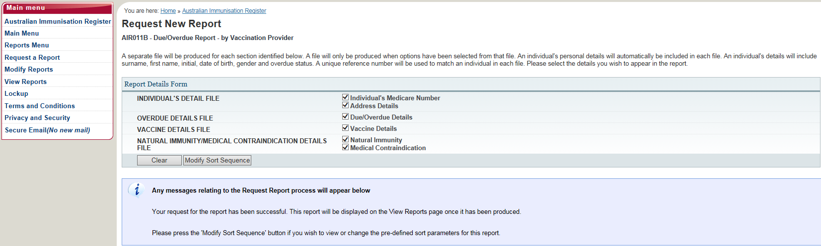

- Select Modify Sort Sequence if you wish to view or change the pre-defined sort parameters for this report.

AIR010A – Due/Overdue Immunisation Practice Report

Report Fields

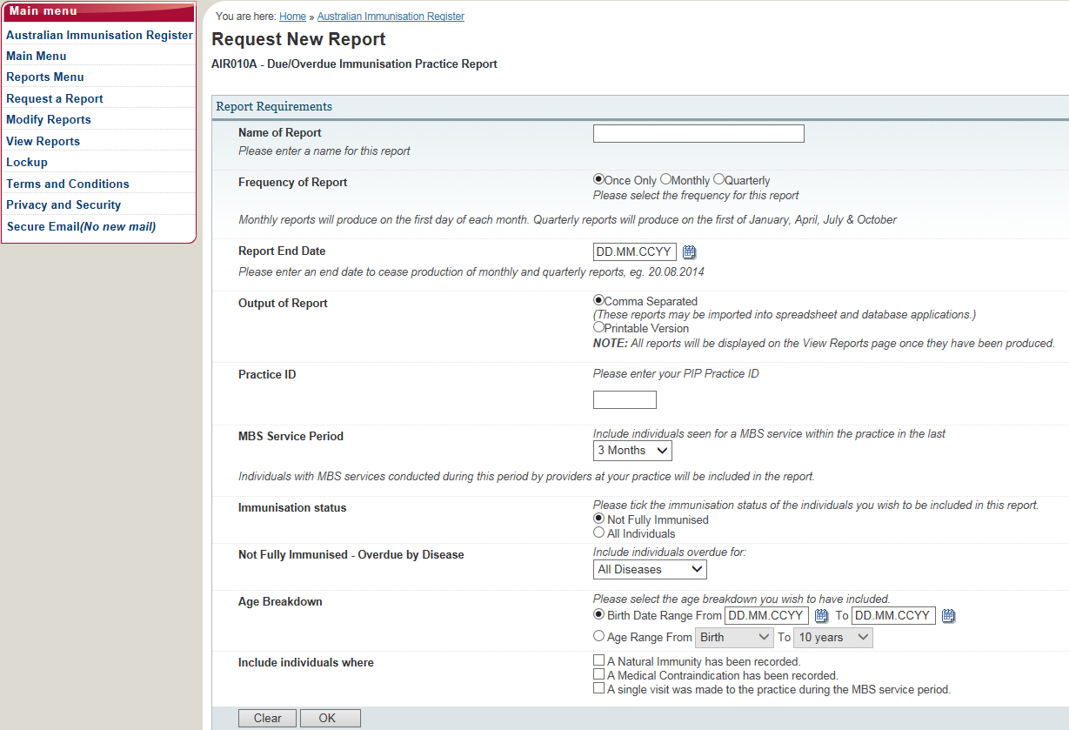

AIR021A – Due/Overdue Report – by Medicare GP

Report Fields

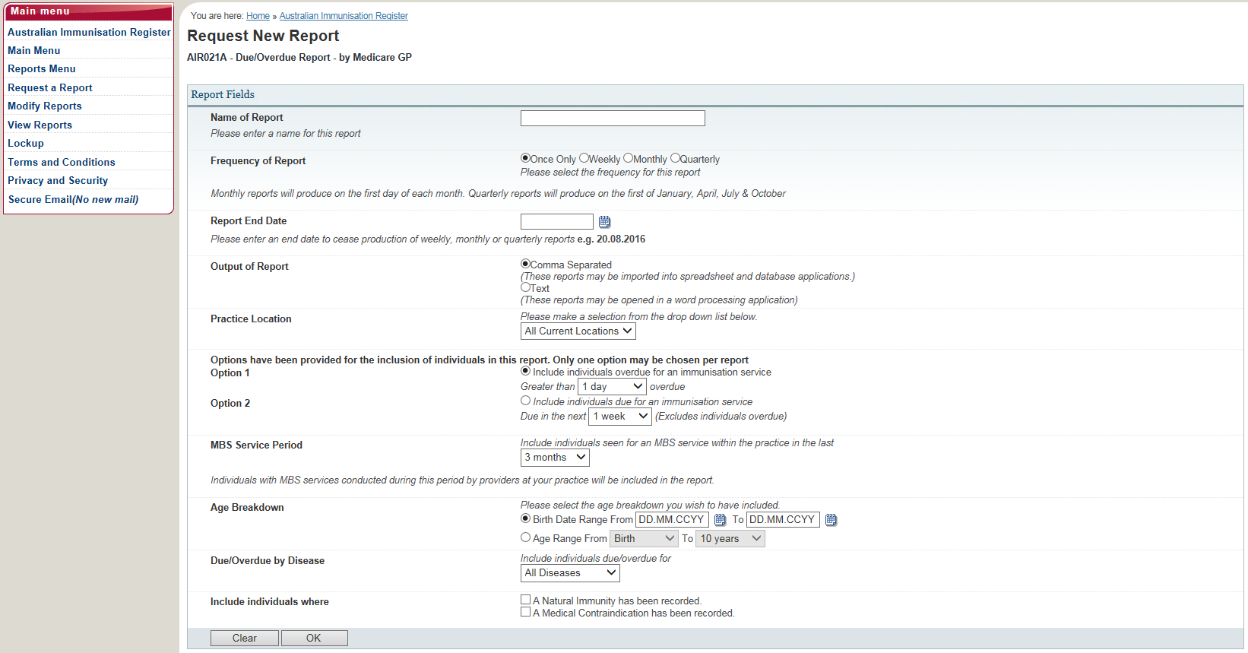

CLAIMS SUMMARY AND STATEMENT OF PAYMENT:

- Claims Summary: displays a summary of claims you have submitted to the AIR. This can display for any 6 month period.
- Statement of Payment: view and request details of payments made for the supply of immunisation encounter information.

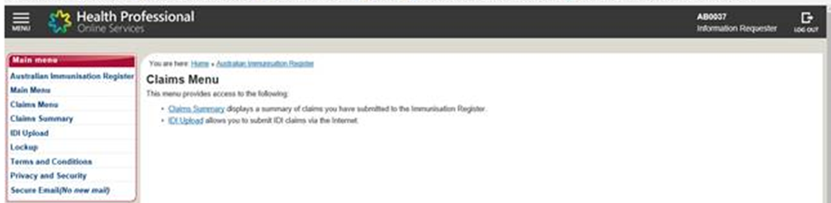

Viewing your claims summary or statement of payment by:

- Selecting the relevant option form the AIR site main menu.

USEFUL FORMS:

The following useful forms can be found at humanservices.gov.au/forms

Australian Immunisation Register (AIR) - Immunisation medical exemption form (IM011)

- You are a general practitioner and would like to notify an individual's vaccination exemption due to a medical contraindication or natural immunity.

Australian Immunisation Register (AIR) - Immunisation encounter header form (IM001)

- Records the vaccination provider's details.

Australian Immunisation Register (AIR) - Immunisation encounter form (IM002)

- Records details of immunisations administered to people in Australia.

Australian Immunisation Register (AIR) - Bank Account Details for Vaccination Providers form (IM005)

- Form to record your bank account details for the purpose of receiving AIR payments.

Immunisation History form (IM013)

- This form can also be used to list vaccinations given overseas.

Australian Immunisation Register - Ceasing correspondence and release of information form (IM017)

- Form for individuals to advise the AIR that the individual does not want to receive correspondence from the AIR or share immunisation information with third parties.

AIR INFORMATION FOR HEALTH PROFESSIONALS:

humanservices.gov.au/hpair

AIR CONTACT DETAILS:

Australian Immunisation Register for Health Professionals

Phone: 1800 653 809 for AIR general enquiries
Phone: 1300 650 039 for AIR internet helpdesk

Email: air@humanservices.gov.au

Post to:
Australian Immunisation Register
PO Box 7852
Canberra ACT 2610

Authorisation for the ‘Application to register as a vaccine provider’ form is done through the Department of Health W.A. The email address is:

Air.authorisation@health.wa.gov.au
REFERENCE

- Information taken from Australian Government Department of Human Services website:
humanservices,gov,au/hpair

This document can be made available in alternative formats
on request for a person with a disability.
© Department of Health 2017
Copyright to this material is vested in the State of Western Australia unless otherwise indicated. Apart from any fair dealing for the purposes of private study, research, criticism or review, as permitted under the provisions of the Copyright Act 1968, no part may be reproduced or re-used for any purposes whatsoever without written permission of the State of Western Australia

